CMPE 281Enterprise software platform

Serverless Framework

The Invincibles

# Media processing serverless Application

Media processing application that allows us to analyze images and videos to detect real world objects in media ﬁles. The results of the analysis can then be queried through the REST API.

# Architecture Diagram:

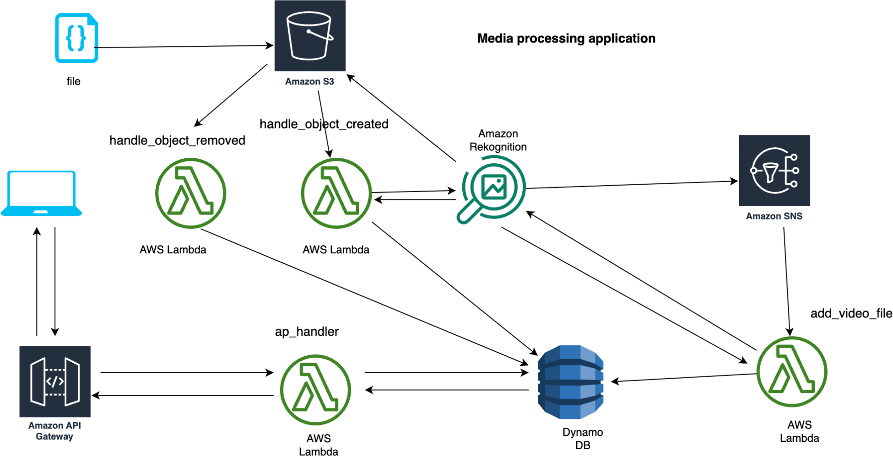

When a picture is uploaded to an S3 bucket, a lambda function is called to process it using Amazon Rekognition. Once complete, the lambda function adds the processed image and stores the labels and date in a Dynamo DB.

A lambda function is called for video processing when a video file is uploaded into an S3 bucket. After the video is analyzed using Amazon Rekognition, one message notification is triggered in SNS. After it is finished, the video lambda function will then save the labels from Amazon Rekognition into Dynamo DB.

Through an API gateway, the app handler lambda function accesses data from Dynamo DB and provides users with information about labels produced by media processing.

* First we need to clone the application I have developed.

<https://github.com/saisankethravva/CPME-281_Serverless>

* **Downloaded and installed all dependencies, chalice libraries and setup virtual environment**

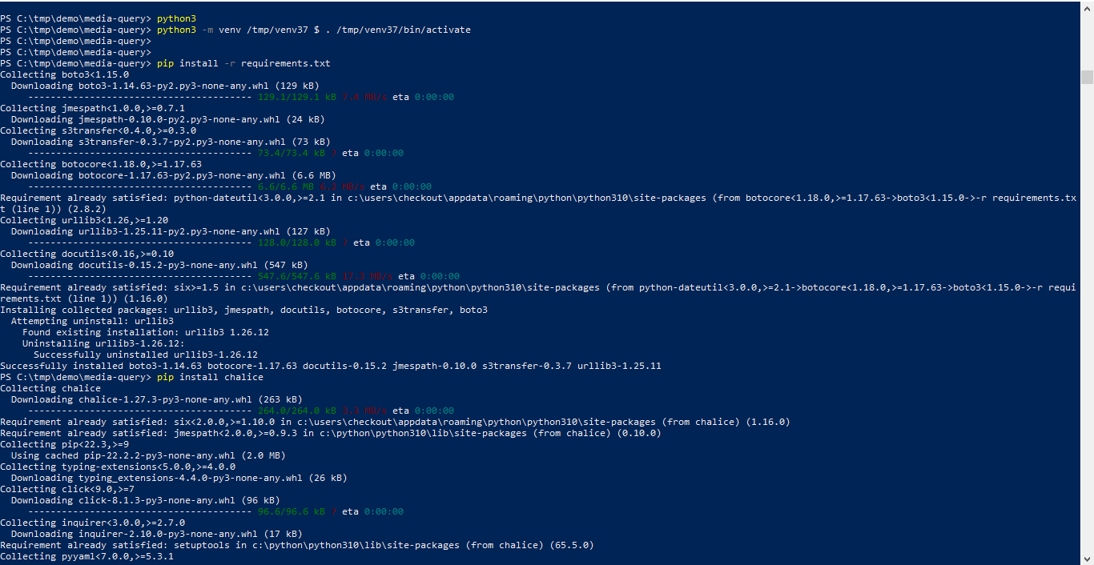

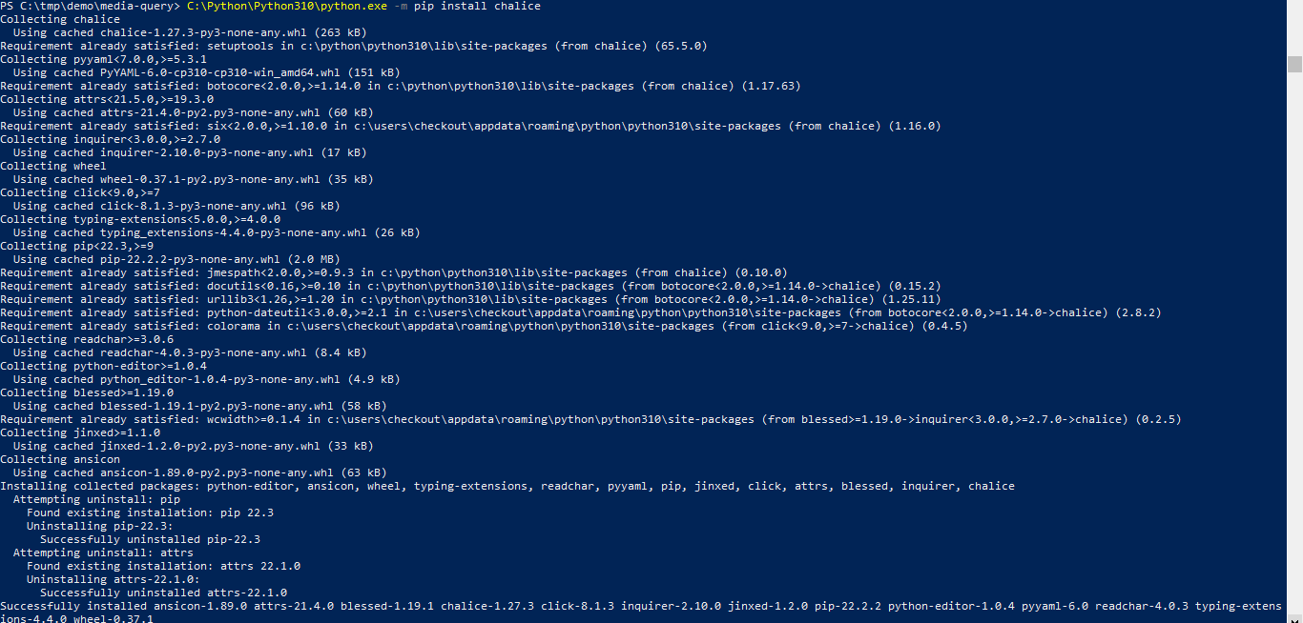

* AWS CLI to deploy a CloudFormation stack containing the S3 bucket,DynamoDB table, and SNS topic needed to run this application.

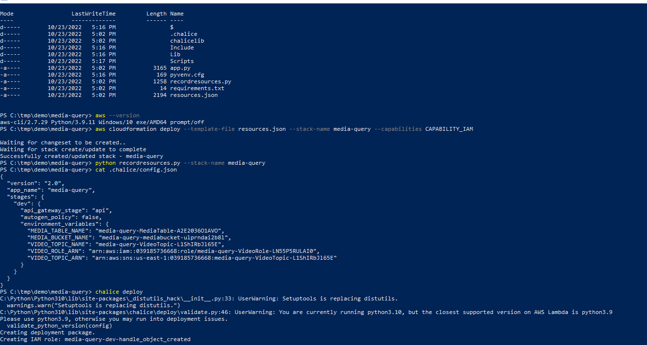

* Deploying Lambda Functions

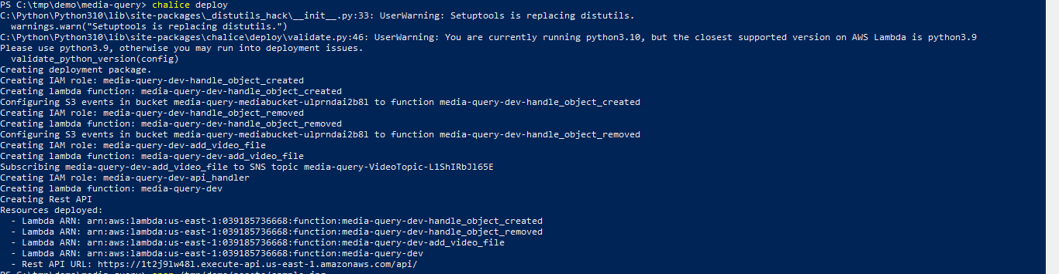

* Execute recordresource.py to create conﬁg.json ﬁle which can be used to deploy the lambda functions. And uploading images and videos into S3 bucket

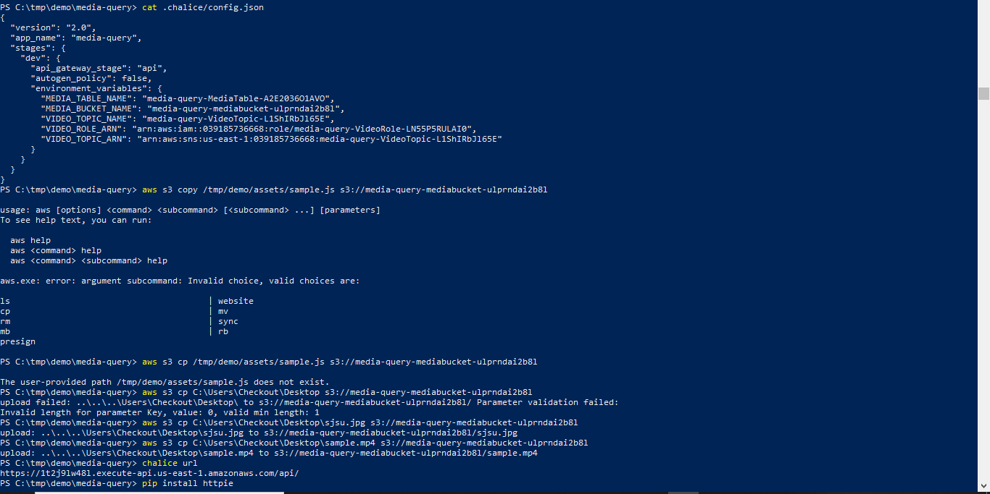

* Installing httpie using pip and getting chalice

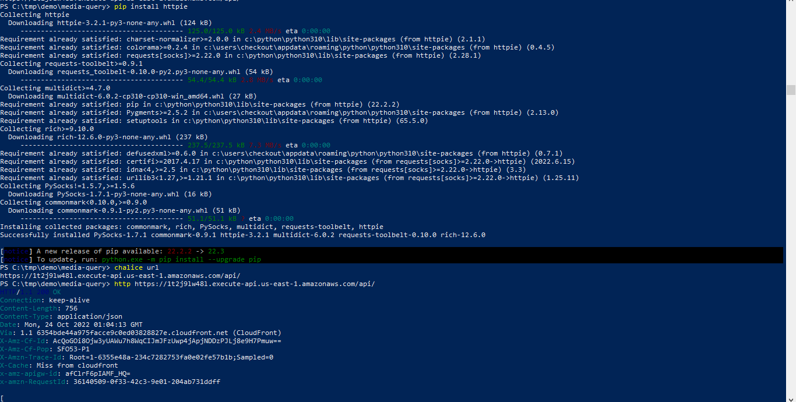

* Getting the AWS rekognition information about media files using chalice http

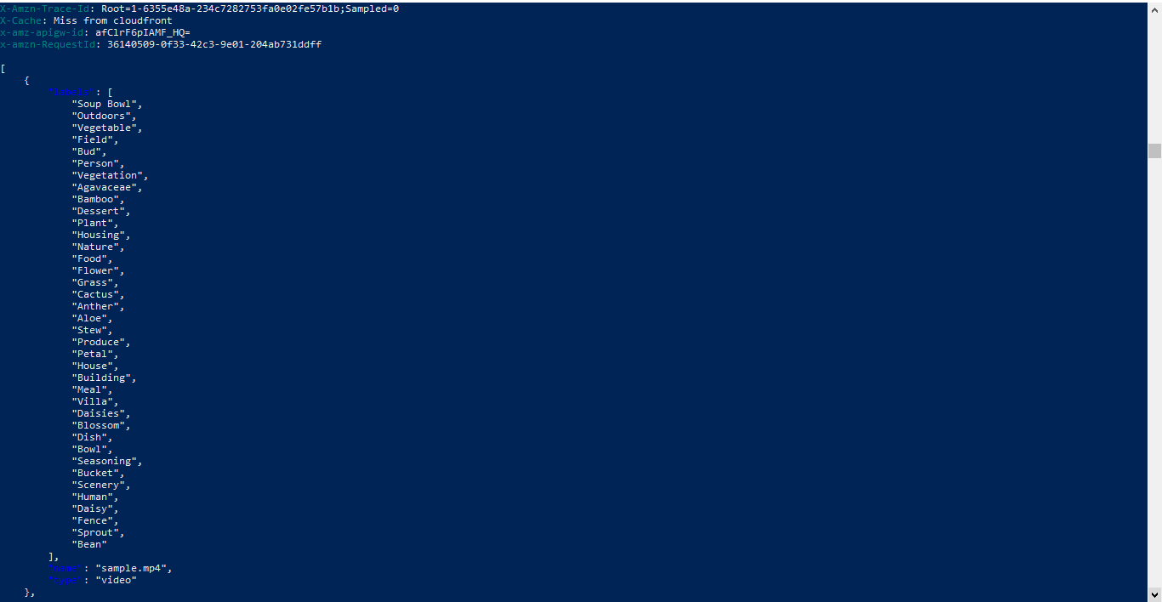

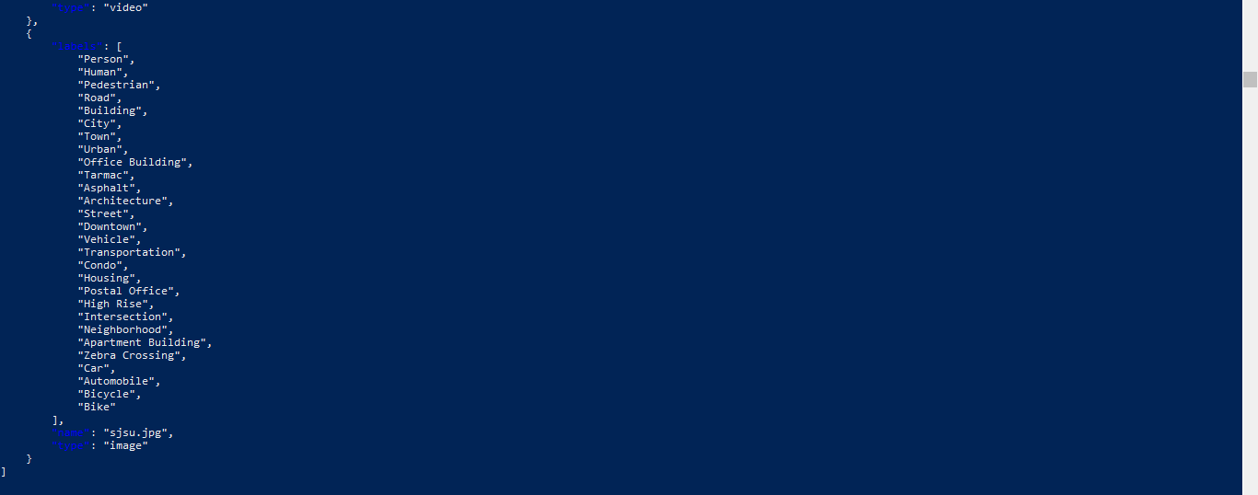

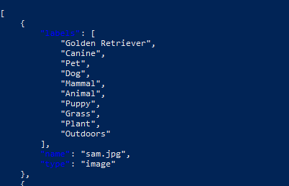

* Images of AWS S3 bucket, Lambda Functions in AWS Console

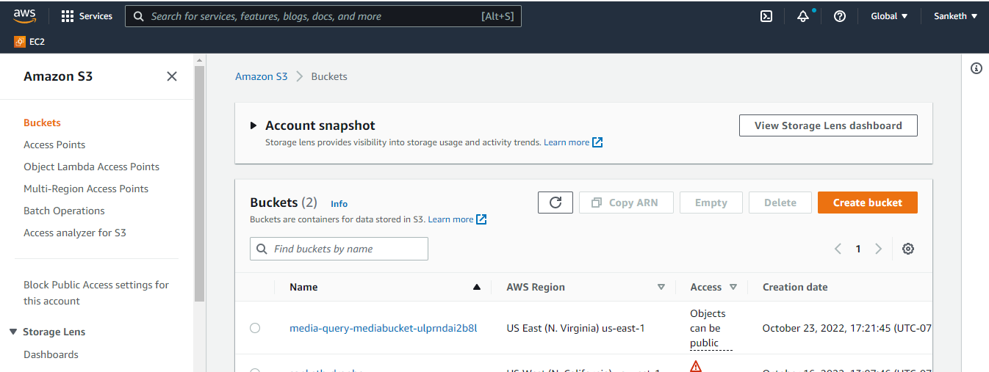

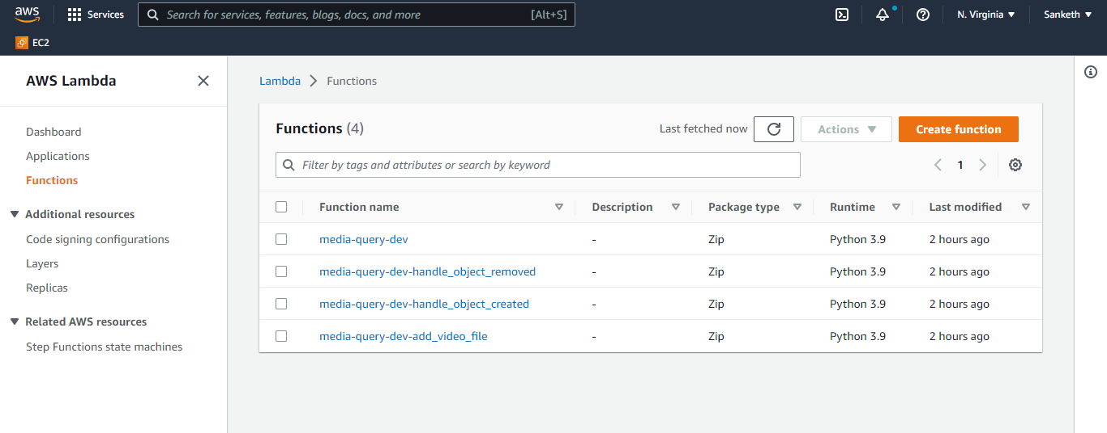

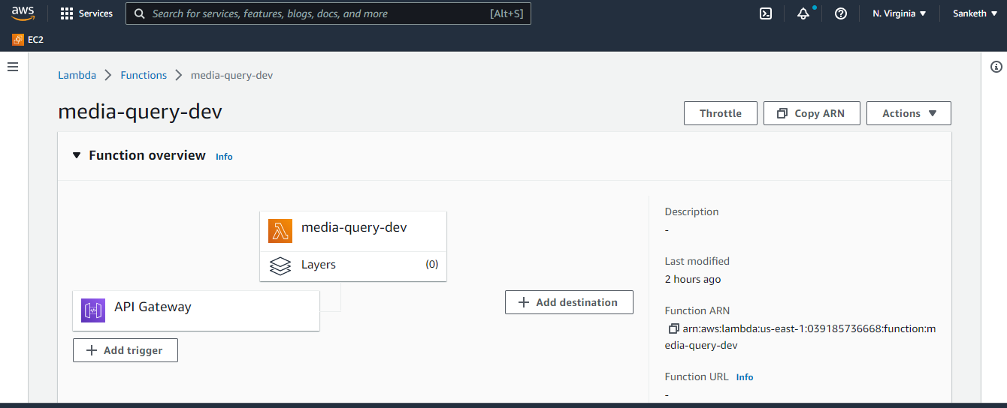

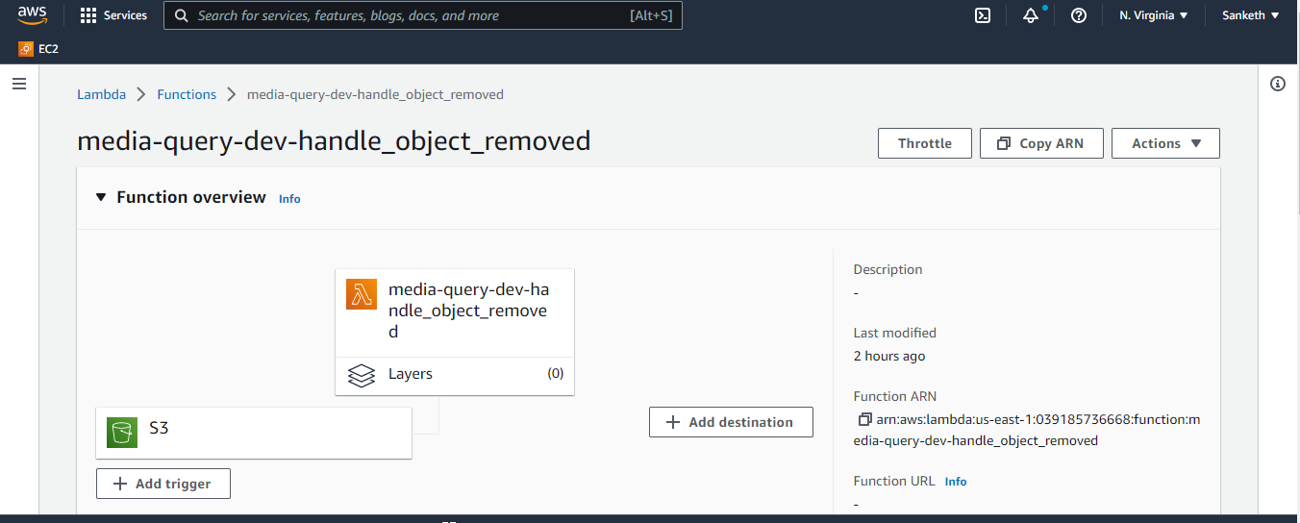

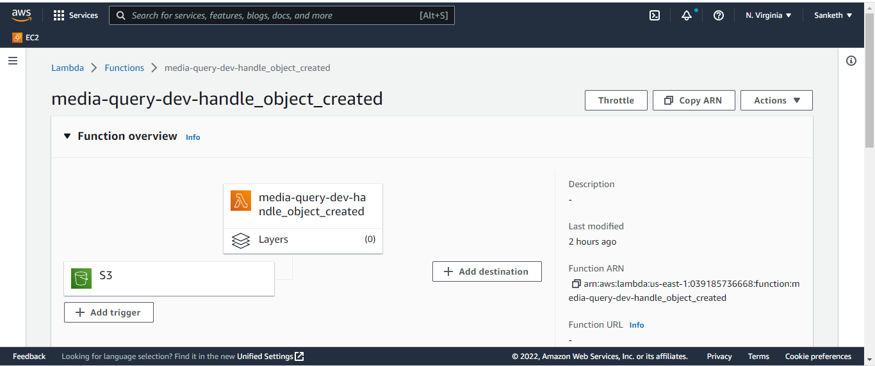

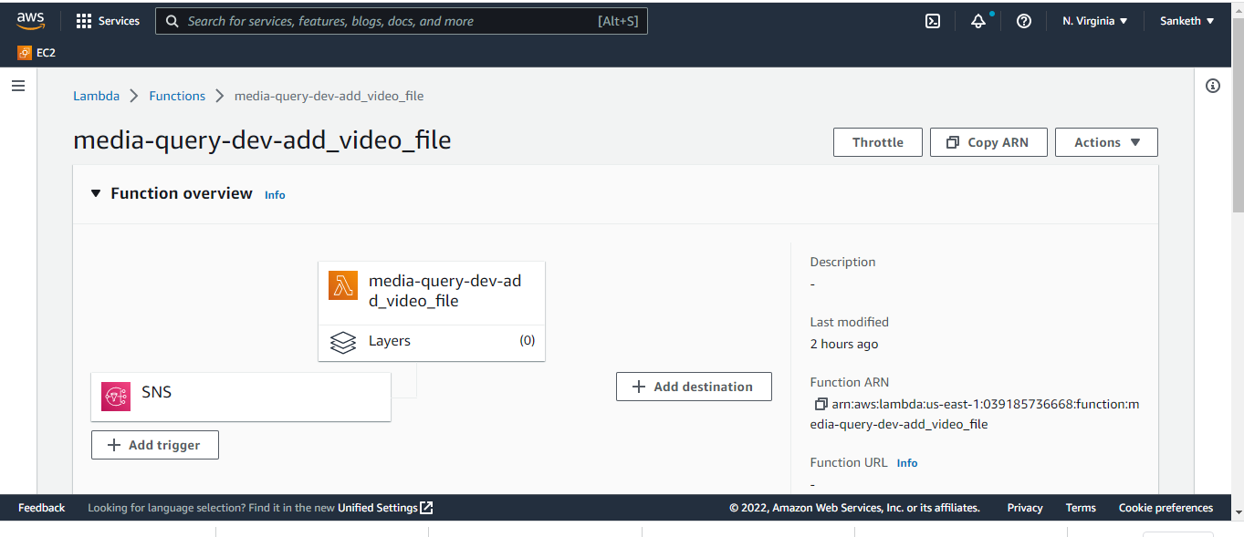

* Images of AWS DynamoDB, AWS SNS, AWS API Gateway console

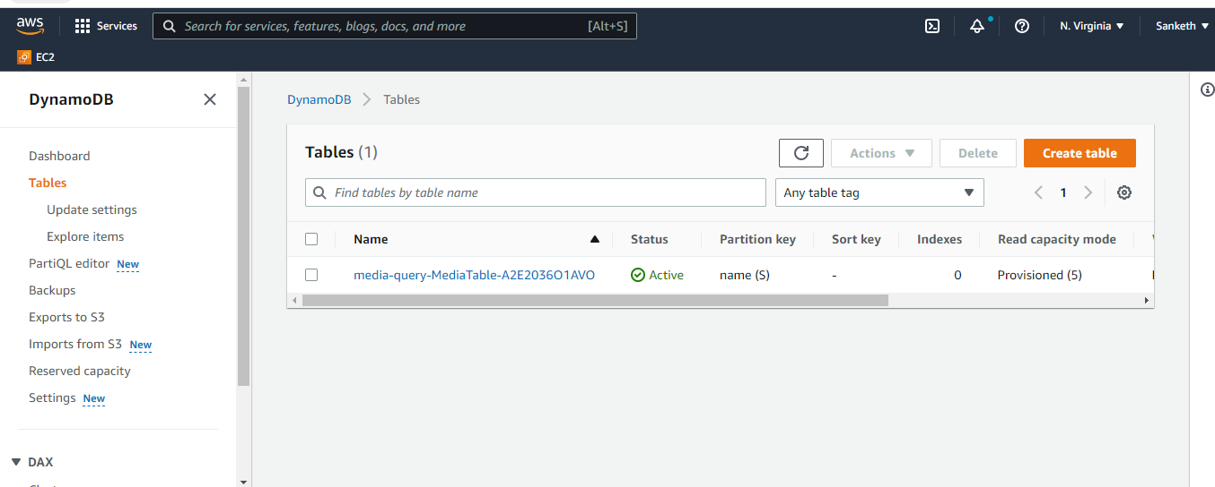

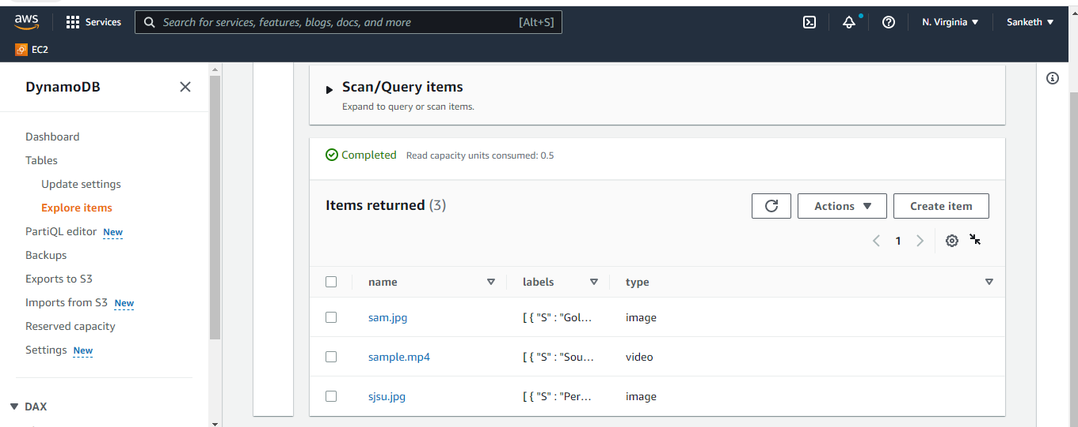

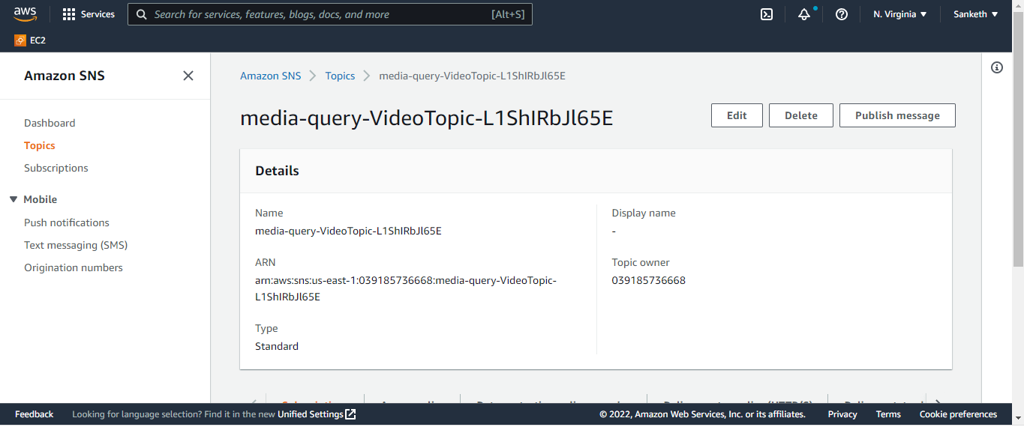

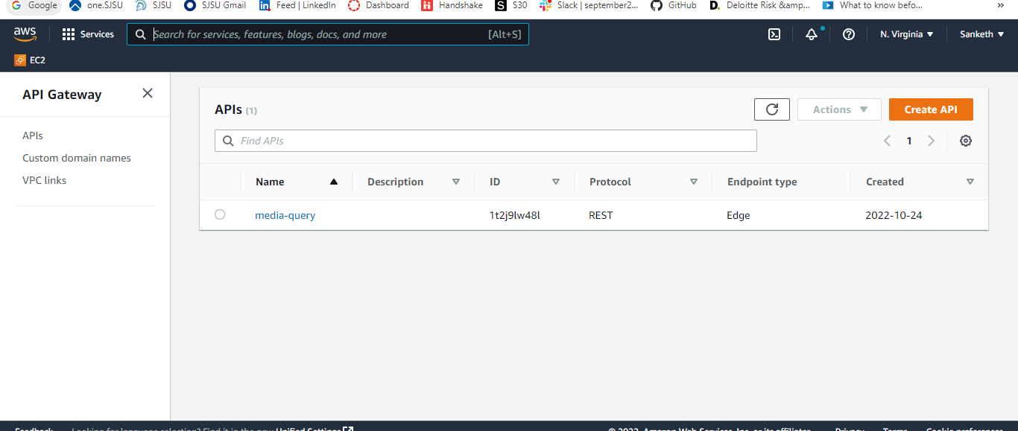

The Chalice url of rekognition data for media files.

* [https://1t2j9lw48l.execute-api.us-east-1.amazonaws.com/api/ startswith==sjsu.jpg](https://1t2j9lw48l.execute-api.us-east-1.amazonaws.com/api/%20startswith==sjsu.jpg)
* [https://1t2j9lw48l.execute-api.us-east-1.amazonaws.com/api/ startswith==sam.jpg](https://1t2j9lw48l.execute-api.us-east-1.amazonaws.com/api/%20startswith==sam.jpg)
* [https://1t2j9lw48l.execute-api.us-east-1.amazonaws.com/api/ startswith==sample.mp4](https://1t2j9lw48l.execute-api.us-east-1.amazonaws.com/api/%20startswith==sample.mp4)

Google Drive link for media files

<https://photos.app.goo.gl/4mdsWrWytfg9En6U6>